LoRa Range Testing

# Introduction

This range test was performed with two modules, the Microchip RN2903 and the REYAX RYLR998. Both modules were tested at maximum power and the configurations were supposed to yield the furthest distance. On the RN2903, we tested two distinct types of antennas. A PCB antenna (Taoglas ILAD.09) and a Flat Patch antenna (Molex Flat Patch Antenna). We were able to achieve two miles with the Flat Patch Antenna and one mile with the PCB antenna on the RN2903. With the RYLR998 LoRa module, we were able to achieve 2.2 miles using the coil antenna that came with the module. We found that, as expected, line-of-sight had a significant impact on the range capability of the LoRa modules. We also found that trees had a significant impact on range as well, with our maximum range decreasing to less than half a mile through dense trees. The testing procedure and results are described in the sections below.

# Test Objectives

The original objectives for this test were to find out the maximum range and data rate of the RN2903 module. The objectives are the following:

* Test the maximum range of the module using different antennas
* Test the data rate of the module using the different configuration settings of LoRa. This includes changing the spread factor, coding rate, and bandwidth.
* Test the power consumption

# Test Setup

Our testing setup can be categorized into two different sections, hardware and software.

## Software

To test the Microchip RN2903 and RYAX RYLR998 modules we used python code to interact with the devices. Python has several libraries available that allow for quick testing. The core library that we were using is called **pyserial**. This library allows us to use serial communication between our computer and the specific module. The following block diagram explains our software architecture:

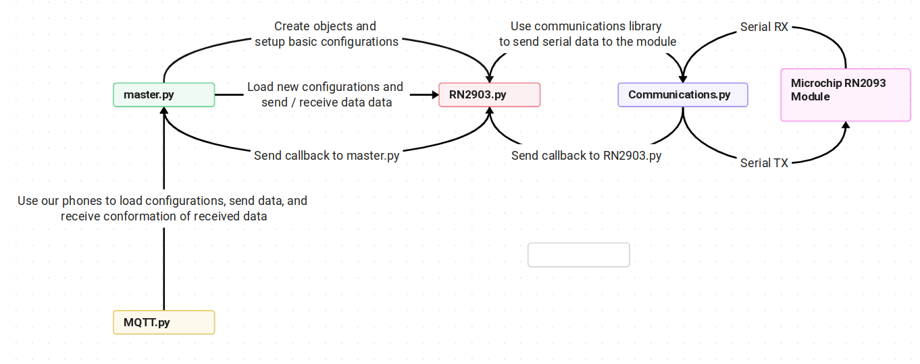

**Figure 1: Software Architecture**

We can see that in *Figure 1,* we set up a linear, object-oriented software architecture using python. This allows us to easily swap out objects to further expand testing and prototyping in the future.

## Hardware

When composing our hardware design, we needed to make a handheld testing unit that was battery powered. This allowed us to test many different distances and antennas easily and quickly.

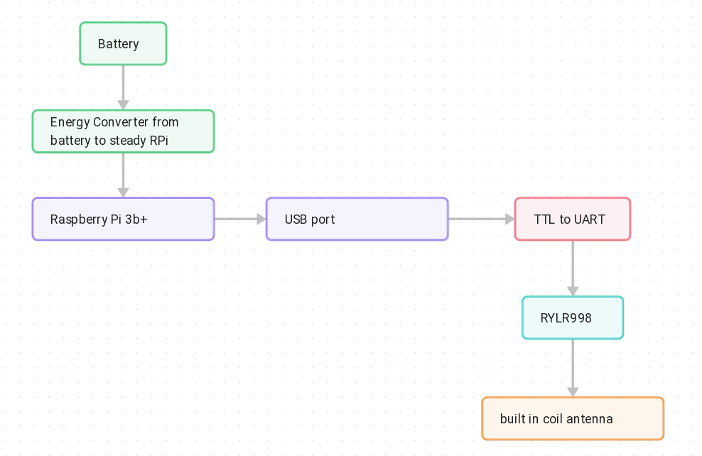

**Figure 2: RN2903 Hardware Block Diagram**

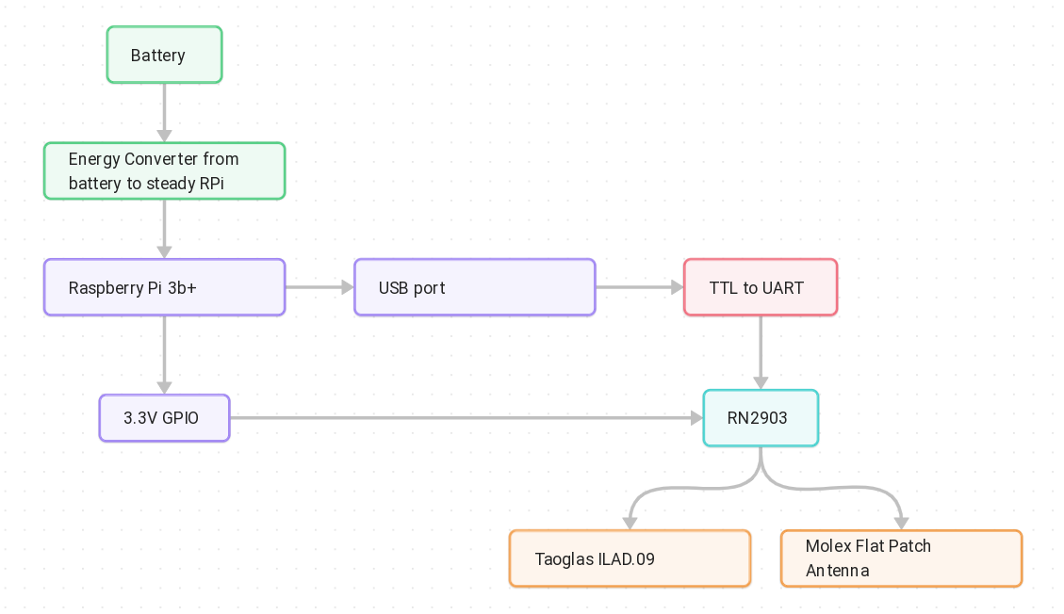

**Figure 3: RYLR998 Hardware Block Diagram**

### LoRa Modules

1. Microchip RN2903

REYAX RYLR998

### Antennas

1. Molex ISM 868/915 - 105262
2. Taoglas ILAD.09 (15MHz Ceramic Substrate Loop Antenna

### Power Supply

1. RPi UPSPack Standard V3P paired with a 3.7V 4000mAh batter from Raspberry Pi Club
2. Subsite Electronics omicharge 71Wh (3200 mAh 22.2V)

### Test Environment

There were several different locations where we conducted testing.

**Test 1:**

Coordinates: 36°18'15.1"N 97°19'43.7"W

Test 1 was conducted upon Knob Hill, as this is the highest point near our location – see *Figure 2*, coming in at 1135 ft (about 345.95 m). One module was placed at the top of the hill located at the above coordinates, while the other was moved further and further to the west in half-mile increments until communication was stopped.

**Test 2:**

Coordinates: 36°17'22.1"N 97°23'24.9"W

Test 2 was conducted in a heavily wooded area at these coordinates: 36°18'15.1"N 97°19'43.7"W. The goal of the second test was to determine how heavily wooded areas would affect the range of the LoRa modules. This test was conducted in a similar manner to that of test 1. We placed one module at the coordinates shown above and moved the second module in .5-mile increments until the signal was lost.

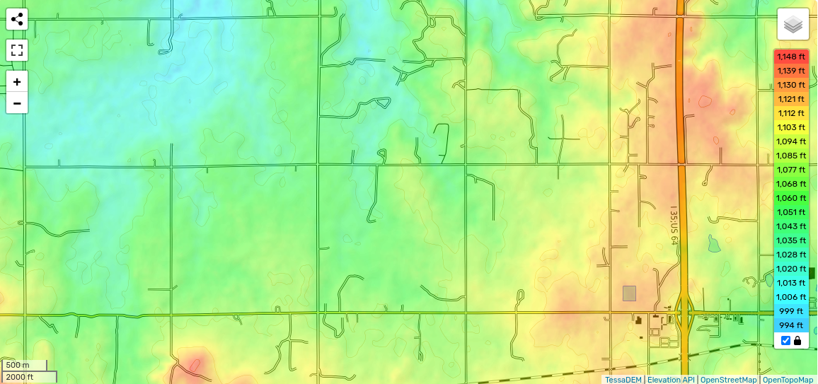

**0.5**

**1**

**1.5**

**2**

**2.5**

**0**

Figure 2: Elevation Heat Map west of I35 with marked testing locations.

### Data Acquisition and Recording

To start our tests and to record the data we used MQTT through our phones. We enabled our private hotspots and connected the Raspberry Pi’s to the MQTT network. Upon receiving a message our MQTT broker alerted us with a message. The usage of this is described more in the code documentation.

# Reyax RYLR998 Results

**Test 1 (Range):**

|  |  |
| --- | --- |
| Distance(mi.) | Transmission Success |
| 0.5 | Yes |
| 1.0 | Yes |
| 1.5 | Yes |
| 2.0 | Yes |
| 2.2 | Yes |
| 2.5 | No |

**Test 2(Tree Interference):**

|  |  |
| --- | --- |
| Distance(mi.) | Transmission Success |
| 0.3 | No |
| 0.5 | No |
| 1.0 | No |
| 1.5 | No |
| 2.0 | No |
| 2.5 | No |

# Microchip RN2903 Results

**PCB Antenna**

**Test 1(Range):**

|  |  |
| --- | --- |
| Distance(mi.) | Transmission Success |
| 0.5 | Yes |
| 1.0 | Yes |
| 1.5 | No |
| 2.0 | No |
| 2.5 | No |

**Test 2(Tree Interference):**

|  |  |
| --- | --- |
| Distance(mi.) | Transmission Success |
| 0.5 | No |
| 1.0 | No |
| 1.5 | No |
| 2.0 | No |
| 2.5 | No |

**Flat Patch Antenna**

**Test 1(Range):**

|  |  |
| --- | --- |
| Distance(mi.) | Transmission Success |
| 0.5 | Yes |
| 1.0 | Yes |
| 1.5 | Yes |
| 2.0 | Yes |
| 2.5 | No |

**Test 2(Tree Interference):**

|  |  |
| --- | --- |
| Distance(mi.) | Transmission Success |
| 0.5 | No |
| 1.0 | No |
| 1.5 | No |
| 2.0 | No |
| 2.5 | No |

# Conclusion

Both modules are capable of very long-range communication and perform identically as far as range and reliability is concerned. The antenna choice has a significant impact on the maximum communication distance. The major limiting factor for the LoRa communication range is line-of-sight. Both hills and trees significantly impact the performance of the LoRa modules. Some future work could be done on exploring how to reduce the effects of line-of-sight on the communication reliability of the LoRa devices.

# Limitations and Future Work

Some of the limitations of testing our LoRa modules come with the difficulty of attaining line of sight past 1 mile. Line of sight is what we found matters the most when it comes to testing, and with the hilly terrain this becomes difficult to test. Another limitation that we faced was the lack of a flat area to test the interference of tree coverage. The area that we found that had significant tree coverage, but was not flat so it was difficult to discern whether the interference was from the trees or the topology. Further, range is significantly affected based on how the antenna is connected to the module. Achieving adequate impedance matching between our antennas and LoRa modules is a difficult but necessary step in finding the maximum range. Further, more careful calculations can be done in understanding the different antenna designs and their impact on impedance matching. In addition to the antennas, the method of attaching the modules may play a key role in achieving long range communication. In our current version of testing, we are using perf boards and cheap TTL to UART converters that might impact the ground plane of the module, thus effecting the range of the device. We recommend making a custom PCB with proper routing and impedance matching to find the maximum range of the devices.

# References

https://en-us.topographic-map.com/map-2jxrrr/Perry/